4.4 ANSWERS TO EXERCISES

4.4 Exercise 1

1. 2-hydroxypropanoyl chloride 2. methyl propanamide
3. propanoic anhydride 4. methylpropyl ethanoate
5. N-ethylpropanamide 6. N-ethylaminoethane or diethylamine
7. 2-hydroxymethylpropanenitrile 8. 2-aminobutanoic acid

9. 10.
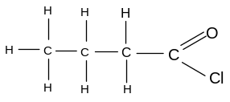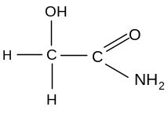
11. 12.
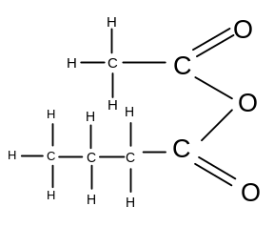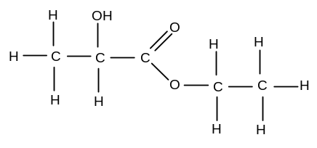
13. 14.
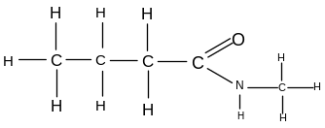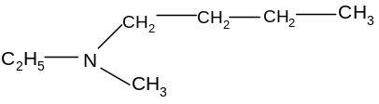

15. 16.
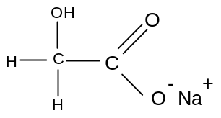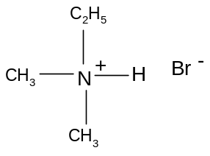

4.4 Exercise 2

1.
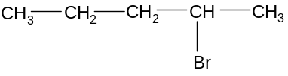
1-bromopentane 2-bromopentane
A B

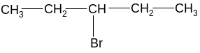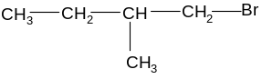
3-bromopentane 1-bromo,2-methylbutane
C D

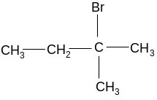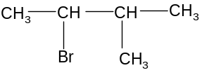
2-bromo,2-methylbutane 2-bromo,3-methylbutane
E F
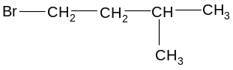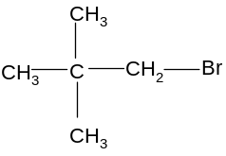
1-bromo,3-methylbutane bromodimethylpropane
G H

a) any two from A, B, C or any two from C, D, E, F
b) two from A, D or G, H or B and E or F
c) B, D and F are chiral
B:
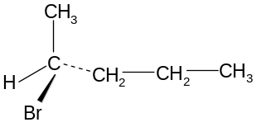 and 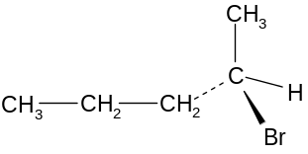
D:
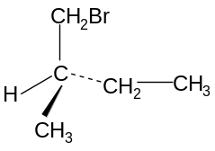 and 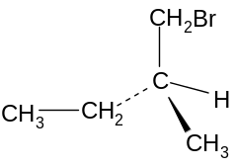

F:
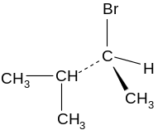 and 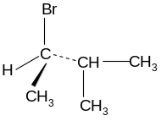

The isomers could be distinguished because they rotate the plane of plane-polarised light in opposite directions.

2.
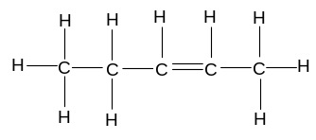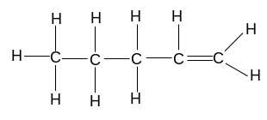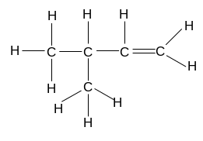
A: pent-2-ene B: pent-1-ene C: 3-methylbut-1-ene
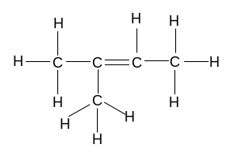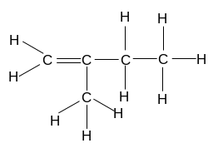
D: 2-methylbut-2-ene E: 2-methylbut-1-ene

a) A and B or two from C, D, E
b) A and D or B and C or E
c) A shows geometrical isomerism
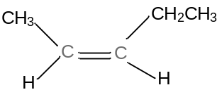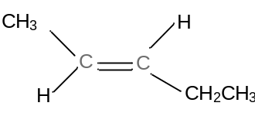
cis pent-2-ene trans pent-2-ene

d)
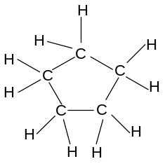

3.
a)
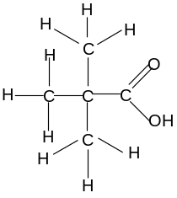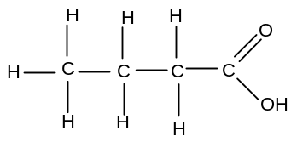
methylpropanoic acid butanoic acid

b) they are esters
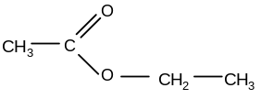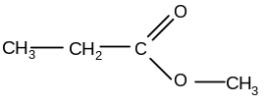
ethyl ethanoate methyl propanoate
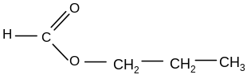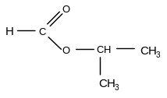
propyl methanoate methylethyl methanoate

They are functional isomers of the carboxylic acids

4.
a) pentan-2-one: b) positional isomer:
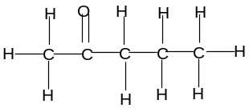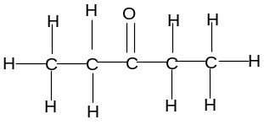

c) chain isomer: d) functional isomer
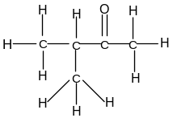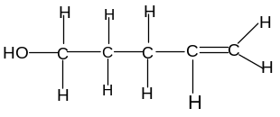

5. a) racemate b) single enantiomer c) racemate

